The first step loads the dataset from the csv file line by line. It then avoids line consisting of Rating score of '99' as it means that user has not rated that Joke.

Then it creates a relationship by creating two nodes consisting of user Id and joke Id linked by their Rating.

The next series of steps are used to calculate similarity distance for a given user to know the users who share similar interests or have given similar rating to the common jokes between them.

The similarity between two users is calculated in terms of the euclidean distance. Here the ratings for a user are thought to be in terms of cartesian co-ordinates and they exist as vectors in multi-dimensional space. The distance between two such points is calculated using the pythagorean formula as shown below:

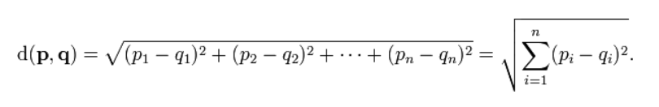

Step 2 performs retrieving all the users who have rated the same jokes as our current user and the total number of such jokes.

Step 3 performs calculation of the similarity relationship that is mentioned above. Here we use the pythagorus theorem to calculate the distance between two user's ratings.

Step 4 finds all the users who have similarity greater than 0.6 with the current user.

Step 5 finds all the jokes that our current user has not rated but other similar users have rated it, also collects the ratings and similarity for that jokes.

Step 6 computes avarage of the similarities and the ratings by using data of the similar users who have rated it.

Step 7 orders in descending manner using the result by length of ratings, average ratings and average similarities and returns the recommended joke and its ratings if average ratings > 2.